**Case Study For Factory Design Pattern**

In Factory pattern, we create object without exposing the creation logic to the client and refer to newly created object using a common interface.

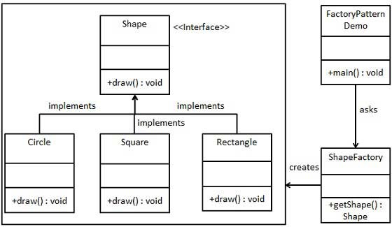

Step 1

Create an interface.

## Step 2

Create concrete classes implementing the same interface.

## Step 3

Create a Factory to generate object of concrete class based on given information.

## Step 4

Use the Factory to get object of concrete class by passing an information such as type.

## Step 5

Verify the output.